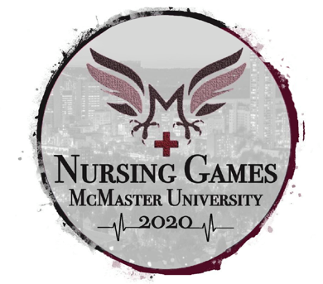
Nursing Games McMaster University Information Package
Questions? Contact:
Nephi Fowler, Year 3 BScN Student
Nursing Society Public Relations Coordinator
University of Windsor | fowlerg@uwindsor.ca

Follow @uwinnursingsoc on Instagram for updates

Hello Nursing students of Ontario! McMaster University Nursing Student Society is happy to host this years time-honored tradition of Nursing Games Ontario! We are so excited to show off our beautiful campus and celebrate 2020 - the Year of the Nurse with you! Please read the information below carefully and contact us with any concerns or questions!

Nursing Games Time and Place

March 20th - 22nd, 2020. Main event day Saturday March 21st.

This year, McMaster University will be hosting Nursing Games 2020 at McMaster’s main campus. 1280 Main Street West, Hamilton, ON L8S 4L8

Typically UWindsor students leave Friday March 20th afternoon/early evening and arrive at hotel around 7:30/8:00pm.
Return to Windsor is on Sunday 22nd after hotel check-out and the optional tradition of team breakfast.

HOW TO RESERVE YOUR SPOT

Spots are reserved on a first-come-first-serve via deposit received.
If e-transfering your deposit, wait for confirmation message before sending your deposit.
- E-Transfer your Deposit
  - Text 519 991 5646 or e-mail fowlerg@uwindsor.ca with subject ‘NG Deposit’
  - Wait for confirmation before sending e-transfer
  - Send e-transfer to uwinnursingsoc@gmail.com
  - Complete this e-transfer form
    - https://docs.google.com/forms/d/e/1FAIpQLSens1Yhuy1ydhLWFf1SZE83SLQ7MLTnGJHg20l7TyLjJH4unw/viewform
  - Smile because you’re on the team

- Hand in cash to UWindsor Nursing Society office Toldo 113
  - Follow @uwinnursingsoc on Instagram or visit nursingsociety.ca to view office hours
    - Hand in cash to a nursing society member
    - Tell them it’s for Nursing Games

After paying your deposit, please e-mail fowlerg@uwindsor.ca with the following:
- STUDENT NAME
- LEVEL OF NURSING Year 1/2/3/4
- T-SHIRT SIZE
- STUDENT EMAIL
- DIET AND PHYSICAL RESTRICTIONS AND ACCOMODATIONS

Registration

- Deposit will be $100CAD to reserve a spot on the UWindsor Nursing Games Team.
- Deposit will be $110CAD to reserve a spot on the team if paid after January 29.
  - Deposits are not refundable, but are transferrable to another student if you provide the substitute
- An additional amount of $40-$70 estimated will be due mid-late February
  - (exact due date and amount TBD after fundraising (see below) and hotel accommodations are finalized)

Fundraising

- Nursing Games team will be hosting a couple of fundraisers with the Year 3 representatives before the additional amount is due.
  - The fundraiser is to subsidize and reduce the additional amount
  - If you are planning on attending, though not mandatory, it is asked that you please consider helping with fundraising efforts to reduce the additional amount

What’s included

What you get:
- Participation in all events throughout the day of Saturday, including;
  - continental breakfast
  - light buffet lunch and
  - formal dinner (with show/performances)
  - door prizes and raffles
  - t-shirt and swag bag
- 2-night stay in hotel with your UWindsor Nursing Games Team

Website and Social Media for Nursing Games

Website: nursinggamesontario.com
Twitter: GamesNursing
Instagram: @nursinggamesontario

Description of Event

Nursing Games is an annual event that brings together nursing schools from across Ontario to compete in athletic, academic and spirit competitions emphasizing teamwork and collaboration. It is a great opportunity to get acquainted with future colleagues, refine clinical skills, solidify evidence-based nursing knowledge - and have fun doing what we all love the most - NURSING!
Nursing students will be divided into two groups through part of the day;
- Amazing Nurse (think ‘Amazing Race’!)
- Simulation Lab
Reconvene as one whole team for sporting events.
Additional Information

University of Windsor Nursing Games Team will be accepting only 30 persons, with priority given to those in 3rd and 4th year.

A limit of four (4) students in Year 1 will be in place until February 11th.
After February 11th, if there are any unfilled spots on the team, we will accept more Year 1 students.
- This is to allow Year 3 and year 4 students who are closer to graduation date an opportunity to participate.

Transportation & Accommodation

Transportation to McMaster university is coordinated by the students;
- carpooling is the usual method and the UWindsor team will have a meeting to coordinate this closer to the event
- if you have any trouble with this, please contact
Hotel Options – Hotel accommodations are included in the additional cost, and will be completed by the Nursing Society Public Relations Coordinator. Details will be finalized closer to the event itself.

UWindsor Nursing Team will be staying all together at one of these two hotels:
- Sheraton Hamilton Hotel
- Homewood Suites Hamilton
For room arrangements please contact Nephi Fowler (page 1)

NURSING GAMES ITINERARY

Breakdown of The Weekend:
**A more detailed schedule will be provided closer to the event date: March 21, 2020**

March 20, 2020 : *CHECK IN*
Teams will arrive in Hamilton, ON Friday night at their destination hotel - each team will be responsible for their own transportation to and from the event.

March 21, 2020 : *MAIN EVENT DAY*
0745 - Team arrival and check in at event
0830 to 0930 - Breakfast and opening ceremonies
0930 to 1015 - Cheer-off
1030 to 1200 - Sporting events & non-academic/athletic activities
1200 to 1245 - Lunch
1245 to 1300 - Teams will separate into their pre-assigned academic activity by captains and go to locations
1300 to 1600 - Amazing nurse, Simulation lab etc activities
1600 - Regroup and take pictures
1600 to 1800 - Prep time for formal dinner
1800 to 2030 – Semi-Formal dinner and closing ceremonies
2100 onwards - Social event

March 22, 2020 : *CHECK OUT*
Teams will be responsible for ensuring hotel rooms are tidied and left appropriately at check out the following Sunday

Required Equipment by Students Attending
- Scrubs (if you are on the simulation team)
- Stethoscope
- Close toed shoes (for all events)
- For Sports Teams: Shorts, Running shoes, T-shirt
- For Closing Ceremony: Business-Formal Attire/formal-causal
- Pen/Pencil
- Water Bottles *** there are lots of re-filling and water stations in and around the campus
- A sweater - you will be walking around campus outside in between events
- Spirit → feel free to bring any (appropriate) swag that will help you represent your team!

Things to eat

Restaurants Near McMaster University
- Joya Sushi - Unit #150, 1685 Main Street West Hamilton, ON, L8S 1G5
- Popeyes - 1711 Main St W, Hamilton, ON L8S 1G5
- Boston Pizza - 1563 Main St W, Hamilton, ON L8S 1E6
- Bean Bar - 1012 King St W, Hamilton, ON L8S 1L4
- The Express Restaurant - 1034 King St W, Hamilton, ON L8S 1L5
- Saigon - 1024 King St W, Hamilton, ON L8S 1L3

McMaster Map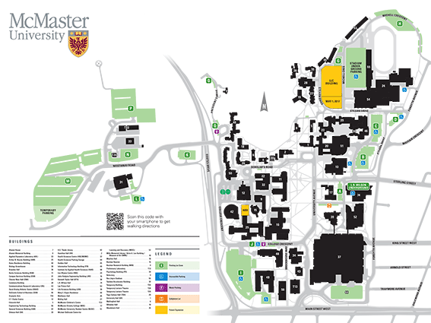
Thank you for your participation in the nursing games and we hope to see you soon!!

